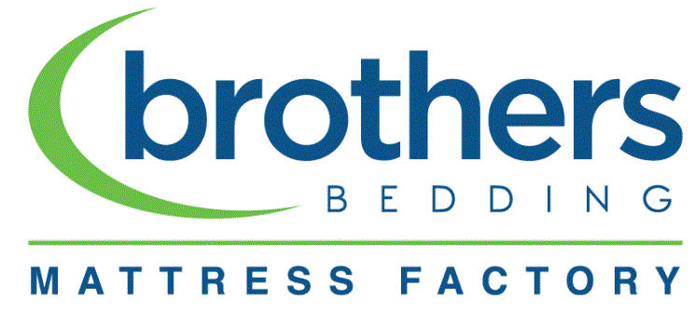

A letter TO OUR dear CUSTOMERS ABOUT CORONAVIRUS: YOUR HEALTH AND SAFETY IS OUR HIGHEST PRIORITY.
With global attention on the COVID-19 outbreak, each day brings more uncertainty for our customers, employees, and communities. As this is a rapidly changing situation, Brothers Bedding Mattress Factory is monitoring it daily and will continue to assess and follow the guidance from leading government and health authorities.
As all Brothers Bedding Mattress Factory locations will remain OPEN, we believe that it’s important to share the steps that we are taking to provide a safe mattress buying experience for our customers and a healthy working environment for our employees:
- We are taking preventative measures and being super extra diligent to keep our stores and factories clean. Our stores are cleaned and sanitized daily and we have increased our associates’ focus on cleaning and disinfecting any commonly used surfaces to ensure that they are wiped down and disinfected several times a day.
- We always encourage our employees who are not feeling well to stay home and have adjusted our attendance policies as to be fair to employees who need to take time away from work.
- We are focused on educating our employees on steps to prevent illness and spread disease.
We will continue to monitor what is happening in our local markets and plan to adjust business operations and policies as needed. Thank you for continued loyalty and be well.

Your # 1 Mattress shopping destination
Brothers Bedding Mattress Factory

